GE Café Stainless Steel
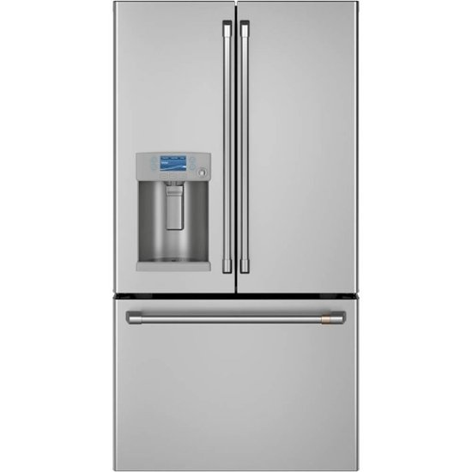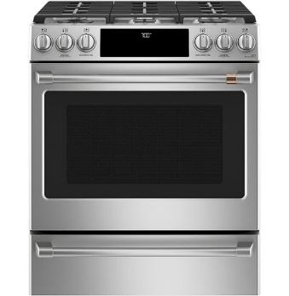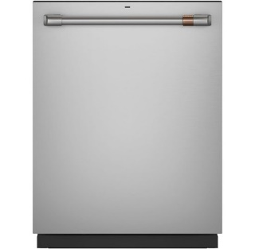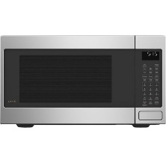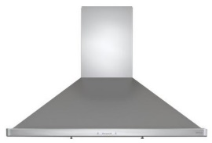
Refrigerator - https://www.cafeappliances.com/appliances/cye22tp2ms1/overview
Gas Range - https://www.cafeappliances.com/appliances/cgs700p2ms1/overview
Dishwasher - https://www.cafeappliances.com/appliances/cdt845p2ns1/overview
Built-In Microwave - https://www.cafeappliances.com/appliances/ceb515p2nss/overview
Range Hood - https://zephyronline.com/product/siena-wall-mount-range-hood/ OR https://www.cafeappliances.com/appliances/cvw73012mss/overview

GE Café Matte White
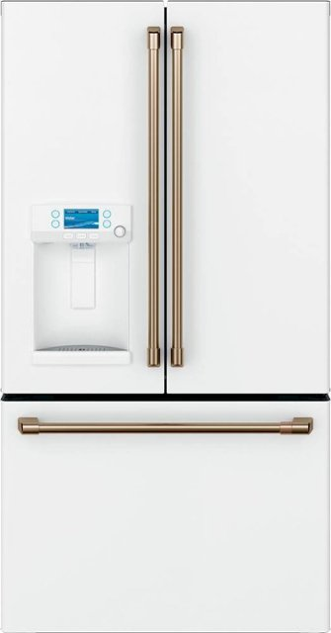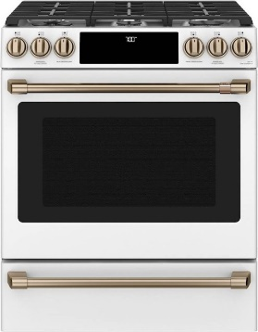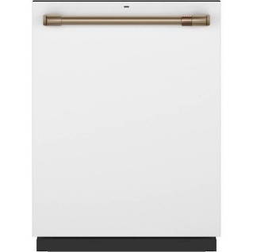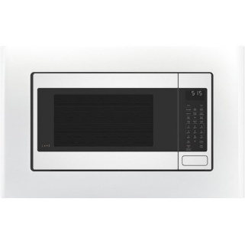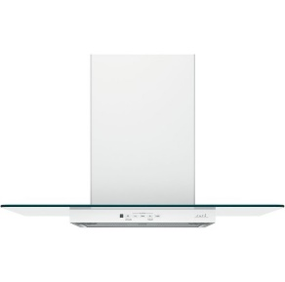
Refrigerator - https://www.cafeappliances.com/appliances/cye22tp4mw2/overview
Gas Range - https://www.cafeappliances.com/appliances/cgs700p4mw2/overview
Dishwasher - https://www.cafeappliances.com/appliances/cdt845p4nw2/overview
Built-In Microwave - https://www.cafeappliances.com/appliances/ceb515p4nwm/overview
Range Hood - https://www.cafeappliances.com/appliances/cvw73014mwm/overview

GE Café Matte Black
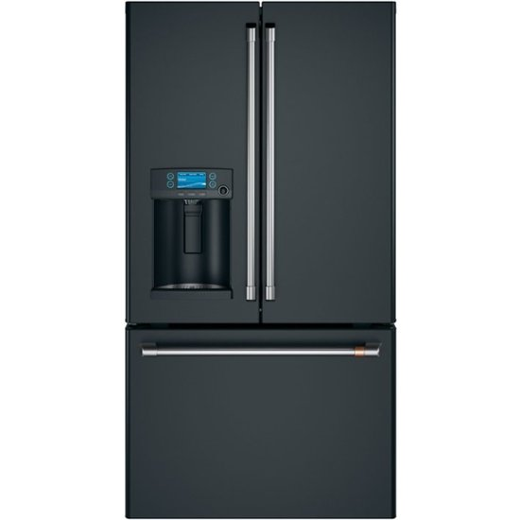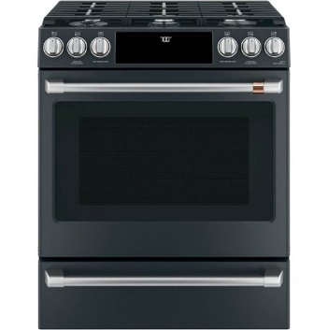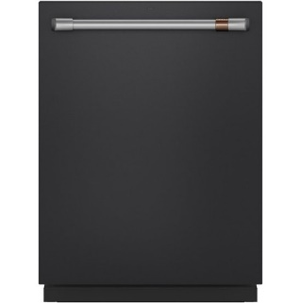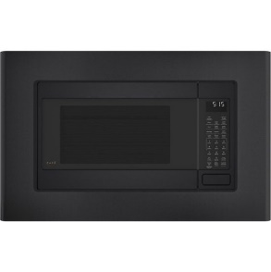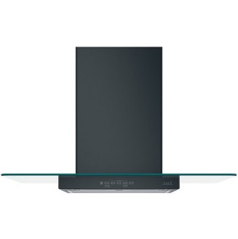
Refrigerator - https://www.cafeappliances.com/appliances/cye22tp3md1/overview
Gas Range - https://www.cafeappliances.com/appliances/cgs700p3md1/overview
Dishwasher - https://www.cafeappliances.com/appliances/cdt845p3nd1/overview
Built-In Microwave - https://www.cafeappliances.com/appliances/ceb515p3nds/overview
Range Hood - https://www.cafeappliances.com/appliances/cvw73013mds/overview

Kitchenaid
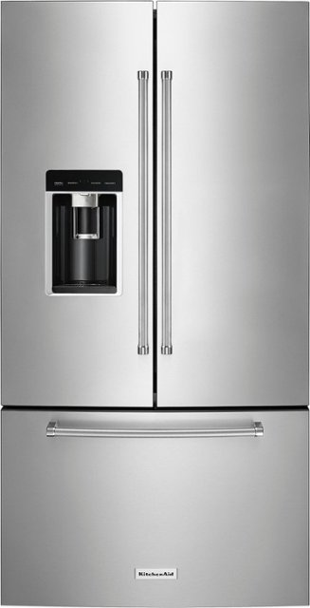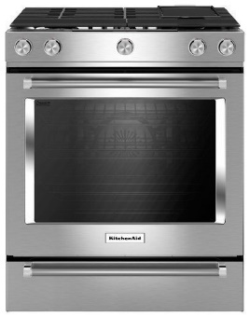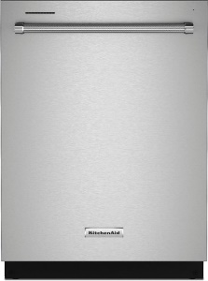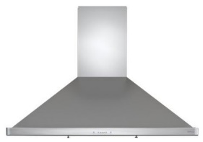
Refrigerator – https://www.bestbuy.com/site/kitchenaid-23-8-cu-ft-french-door-counter-depth-refrigerator-printshield-stainless/5508007.p?skuId=5508007
Gas Range – https://www.kitchenaid.com/major-appliances/ranges/slide-in-ranges/p.30-inch-5-burner-gas-convection-slide-in-range-with-baking-drawer.ksgb900ess.html
Dishwasher – https://www.kitchenaid.com/major-appliances/dishwashers/integrated-control/p.44-dba-dishwasher-in-printshield-finish-with-freeflex-third-rack.kdtm404kps.html
Built-In Microwave – https://www.kitchenaid.com/major-appliances/microwaves/countertop/p.21-3-4-countertop-convection-microwave-oven-1000-watt.kmcc5015gss.html
Range Hood – https://zephyronline.com/product/siena-wall-mount-range-hood/ OR https://www.kitchenaid.com/major-appliances/hoods-and-vents/wall-mount/p.30-modern-glass-wall-mount-range-hood.wvw75uc0ds.html

